Hisee Android User Manual

1 Preface
Thanks for using our product，we will try to provide you best service.
The user’s manual is just for reference, if there is update, we will add in new edition.
The user’s manual may contain print or description error.If any,please kindly let us know your suggestions,we will improve accordingly.

2 Summary

1 Main Functions of Hisee
The user manual mainly introduces how to set and use Android edition Hisee Video Surveillance app。
Hisee app provides user with Features of browsing video, remote control IPC, NVR equipment and so on, and the features are below :
- Support wireless wi-fi,3G and 4G network connection
- Support equipment management
- Support two-dimensional code scanning、add device in LAN
- Support 1ch/4ch video browsing
- Supports vertical /horizon viewing mode switch
- Support PTZ control
- Support figure picture control direction of rotation
- Support capture and browsing
- Support local recording and playback
- Support two-way voice intercom
- Support remote video playback
12）Support Remote alarm features

2.2 Operating Environment of Hisee
Operating system：Android；
Edition model：Support 4.0+；
Network environment：Wi-Fi、3G、4G；
CPU：1GHZ dual-core and above；
RAM：1G and above；

3 Software installation
Please search the software in the google play or apple store with the key words“Hisee ” and download .Then click to download and install.
After installation，the program will generate an icon named “Hisee” .
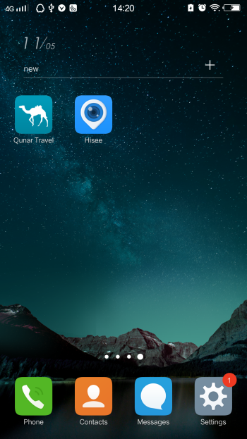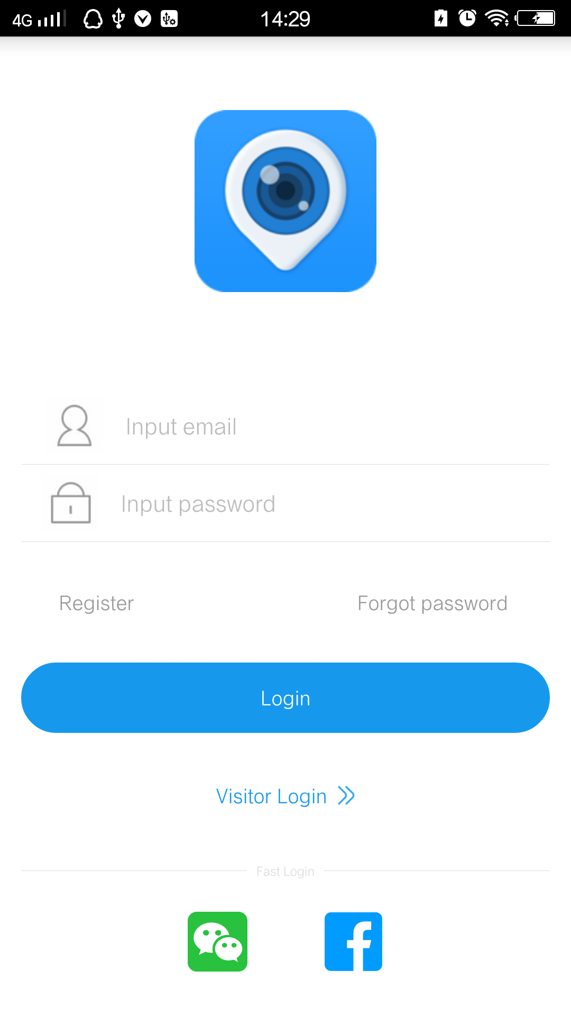
Hisee icon Hisee startup

4 Software using
Before using the software, the user must log in the APP by account password.
Otherwise,the user can login as visitor login or fast login mode.
Note:
1. Visitor login: The device will only be saved in the current phone,in Local LAN .
2. Fast Login:Click the WeChat or Facebook icon,the software use WeChat or Facebook account quick login.
4.1.1 Registration
The register steps is below.
Step 1: Opening the software, click “Register” button to enter the registration menu
Step 2: Input the mail, password and confirm password, then click “Register” button to Complete registration.

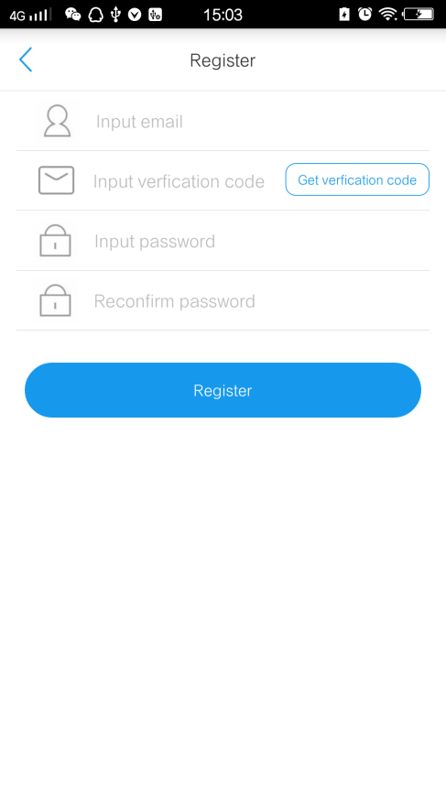
Registration Interface

4.2 Login
Input register email name and password,then click “Login” button to enter main interface.
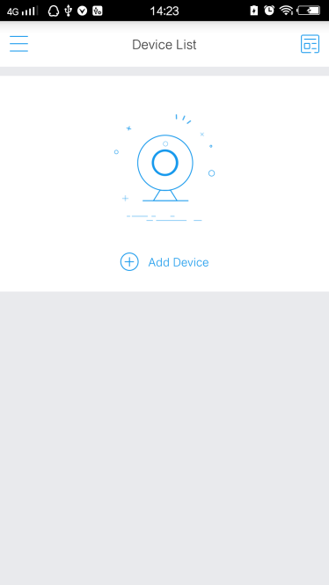
Login interface device list

4.3 Device management

4.3.1 Add equipment
Click the button“”in the program main interface，will pop up the "Add Device" box，then choose how to add based on the device type.
If you device connect to the Internet through WIFI,please choose “Wireless device” mode to Configure WIFI,otherwise choose the Wired device mode.
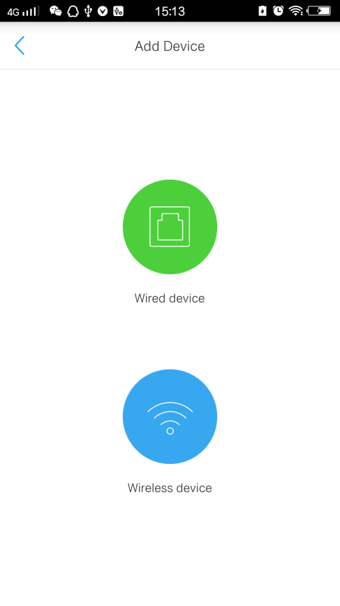
device add way

4.3.1.1 Add Wired device
There are 3 methods to add device ID.
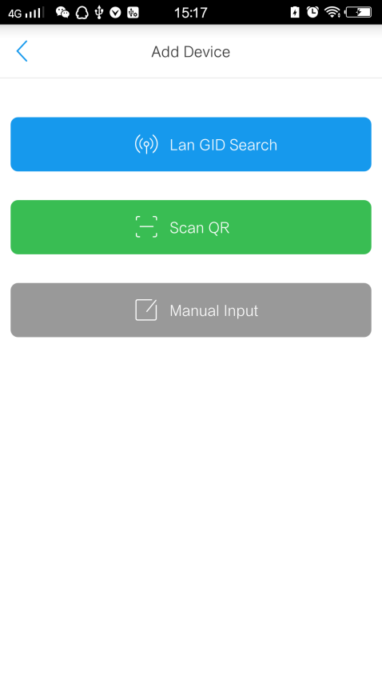
Method 1：Click “LAN GID Search” button, search all the devices in the intranet, the list shows a series of device ID number,select any one of them to add.
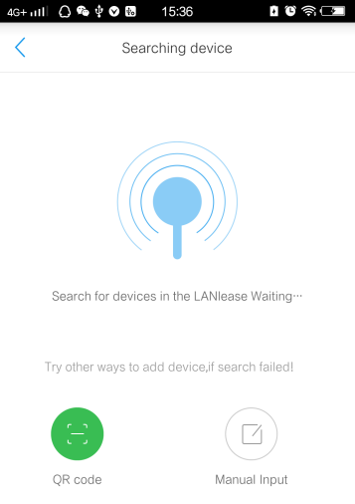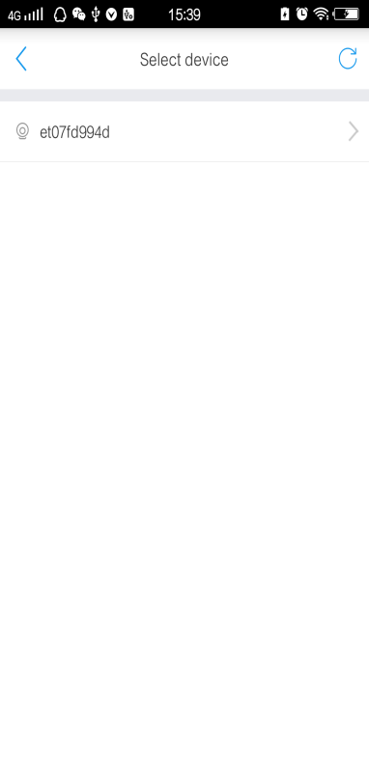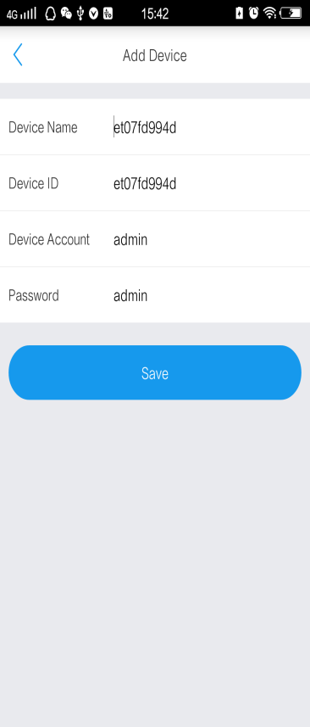
Method 2：Click “Scan QR” button,align device QRcode within frame to add device.
Method 3：Click “Manudal Input” button,to input device name,ID account and password directly.
Description of input item：
Input item | description
Device name | Customer customize，attention the name cant be same with added one
Device ID | GID of device，（if you use scan QR code/Intranet Search way add device It will be filled in automatically），Be careful not to add the same name already
Device account | User’s name of device login,the default is admin
password | Password of the device

4.3.1.2 Add Wireless device
There are 3 methods to add wireless device ID.
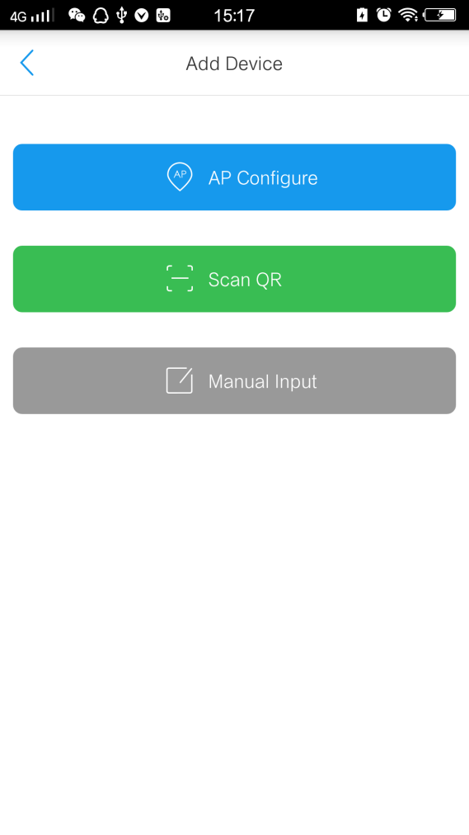
Method 1：Click “Scan QR” button,align device QRcode within frame to add device.
Method 2：Click “Manudal Input” button,to input device name,ID account and password directly.
Method 3：Click “AP Configure” button, to configure WIFI to device and add device to APP.
The AP Configure steps is below.
Step 1: Click “AP Configure” button,enter “Ap configure” interface , then click “” button to start searching device.
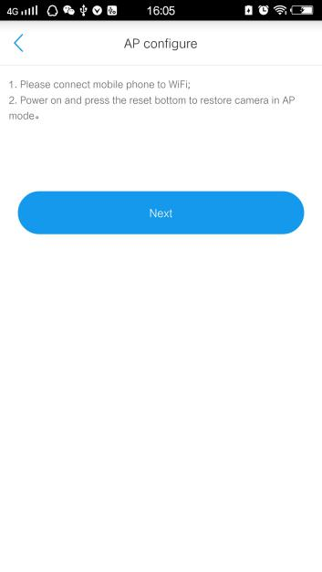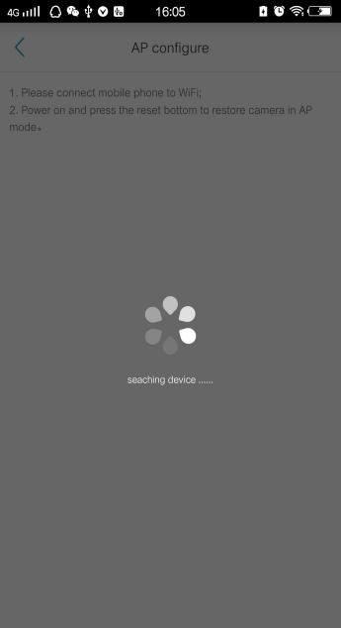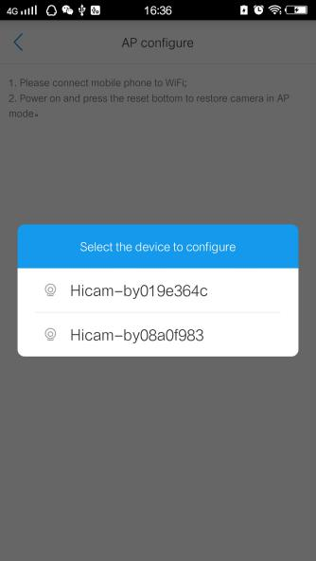
Step 2: Input the WIFI name and password.Press “Start” button to send WIFI information to device.If success, it’ll pop notice“Command was sent successfully,the device is configured”.
Step 3: After configured,press “sure” ,the device information will be added automatic.
Step 4: Modify the device name and password then press”” to finish.

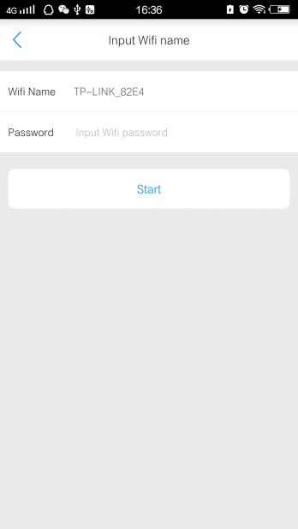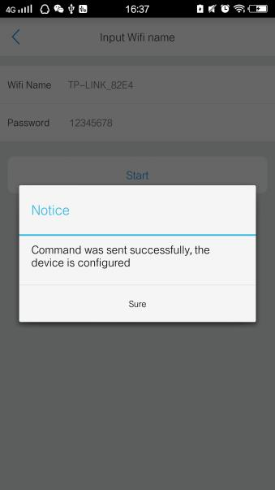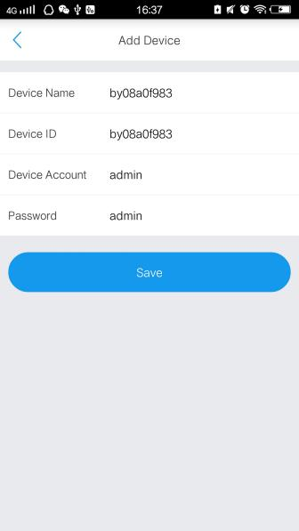

4.3.2 Edit/delete device

Select device and slide left，edit and delete options shows .
Click “”button to delete device from list.
Click“”button,jump device information editing window,and “Advanced Settings”, “Device Maintenance” button appears. you can modify device name , device password.
After modify the information，click top right “”button，software will automatically safe the info and return to “device list “ interface. If give up modify ,just press return key of mobile.
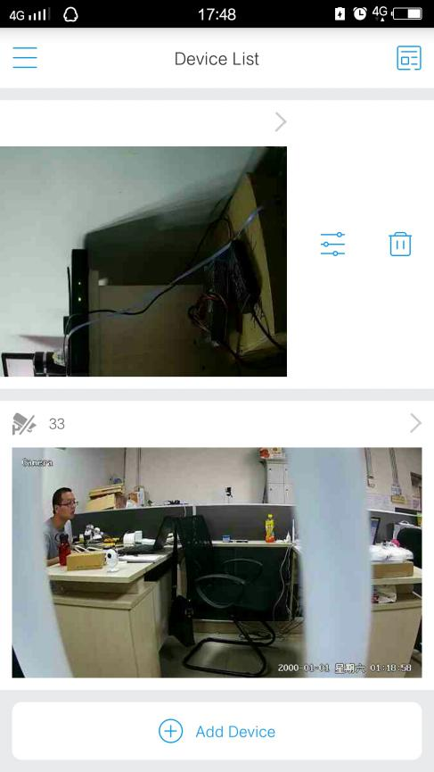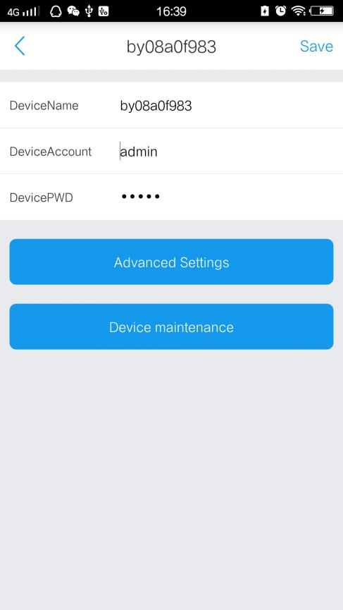

4.3.3 Advanced Settings device
Click button  to enter the parameter configuration window. You can modify device’s password,motion detection ,planned record,time settings, imae settings,SDcard, WiFi config,Audio setting as like.
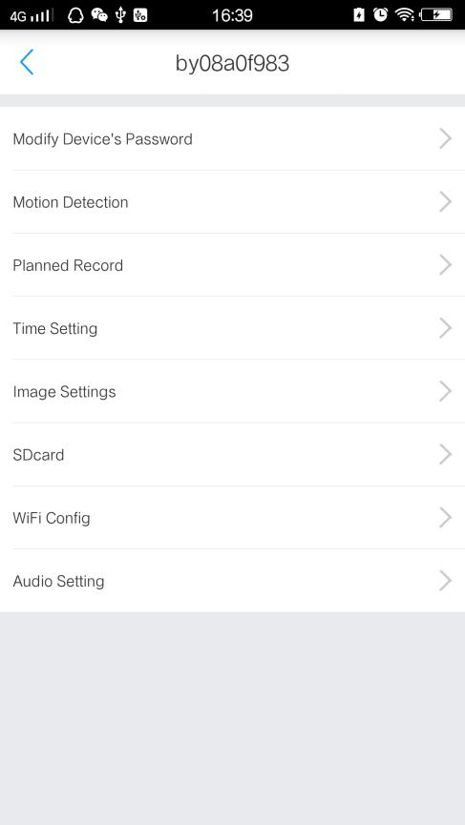
4.3.3.1 Modify device’s password
Input old device password and set the new password for device。.
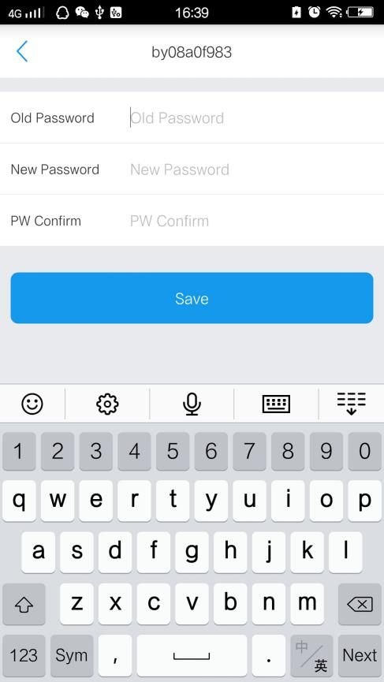
4.3.3.2 Motion detection
Set motion device on or off，the sensitivity，storage type，and plan effective time of the alarm was triggered.
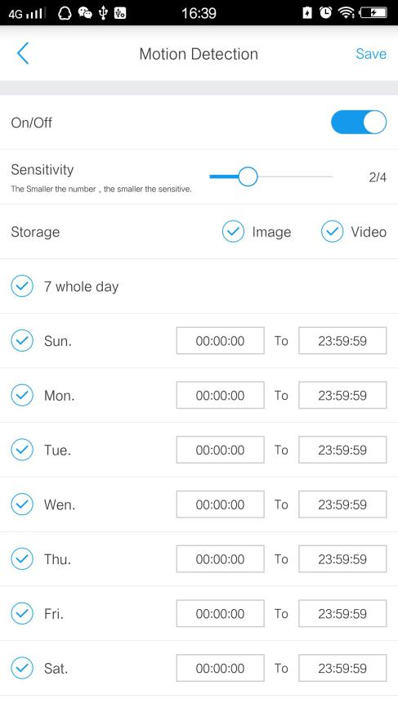
4.3.3.3 Planned record
Set to save the video recording plan time and video stream in the TF Card.

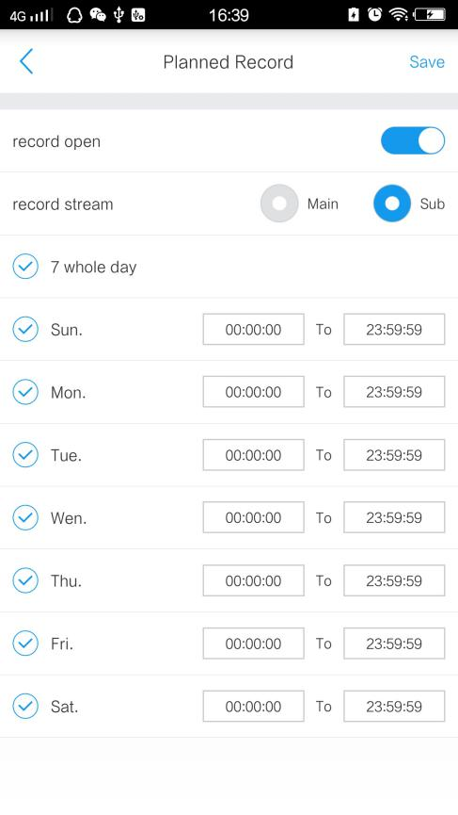
4.3.3.4 Time settings
Click “Time setting” to sync device time from mobile phone.
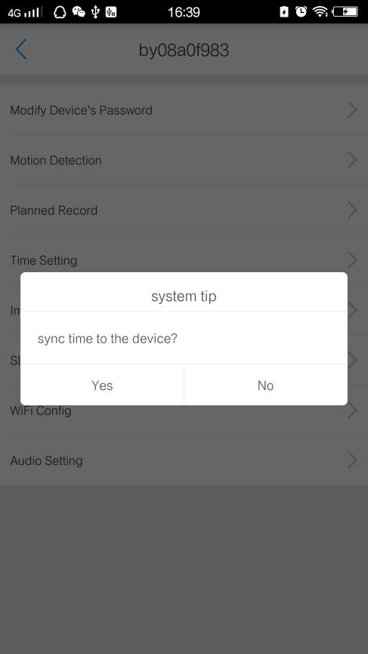
4.3.3.5 Imae settings
Set horizontal or vertical flip for image.
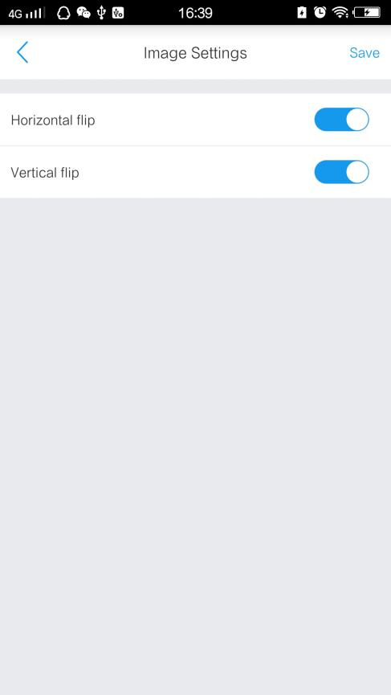
4.3.3.6 SDcard
View the memory information of SDcard. User also can format SDcard in this window.
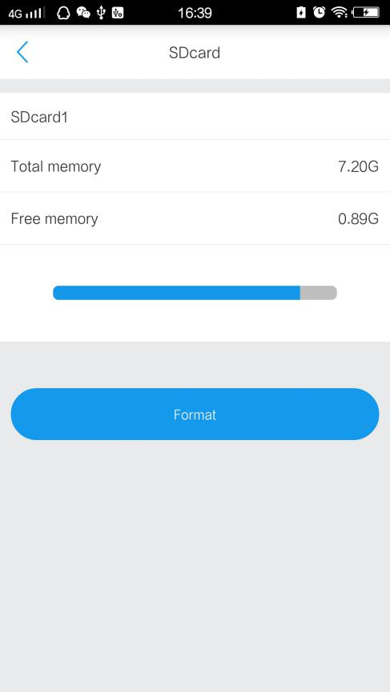
4.3.3.7 WiFi config
Set the WIFI hotspot which you want to connection for your device。

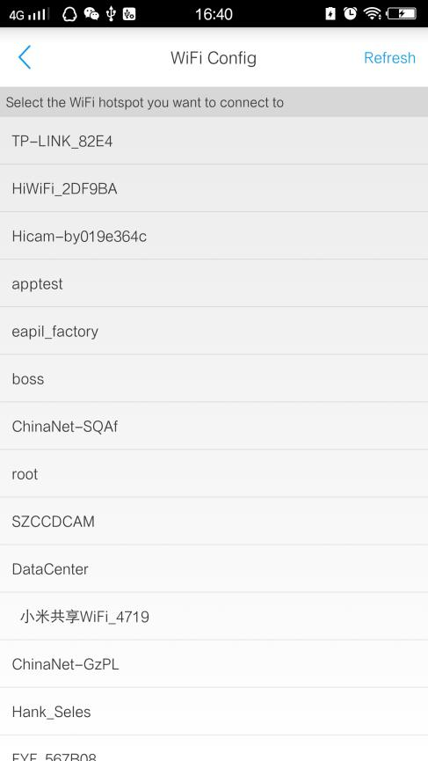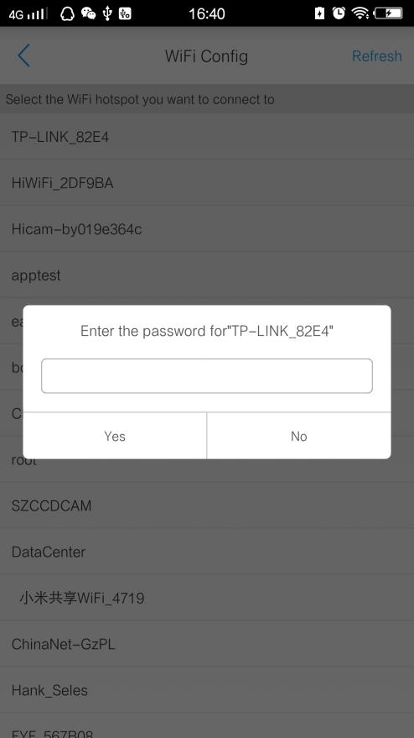
4.3.3.8 Audio setting
Adjust the audio input and output volume of device.
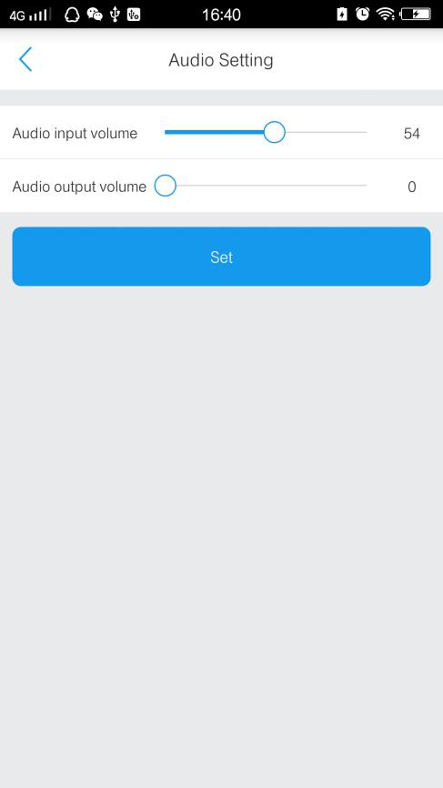

4.3.4 Device maintenance device
Click “device maintenance” button, prompted to device password input window, after enter device password，you can update firmware,reboot or reset device.

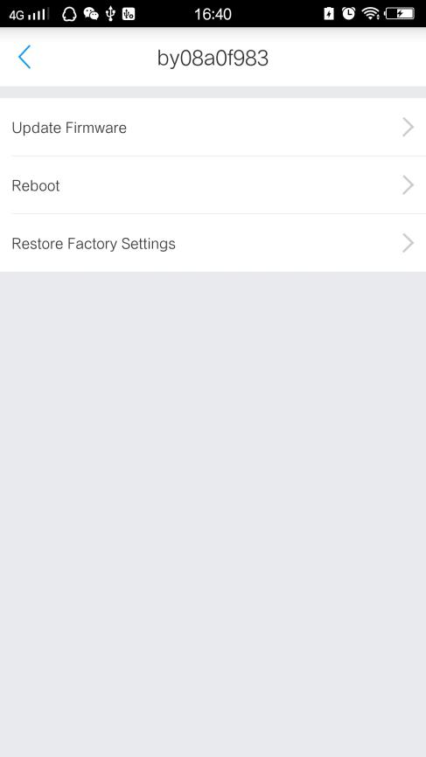

4.4 Live view
Click on the online device in device list, you can watch the real-time video window, and control or configure the device.
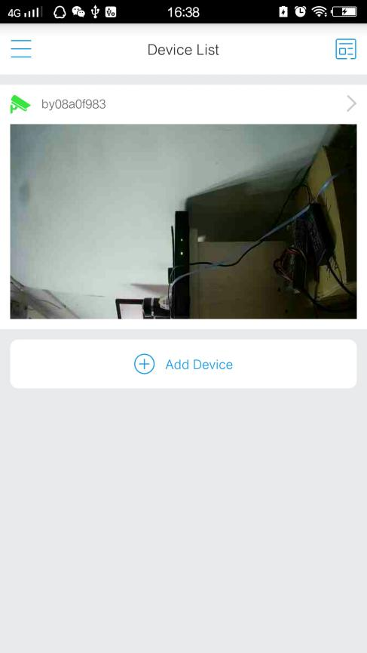Note: The green icon "" above the channel indicates that the device is online, "" indicates that the device is offline.

4.4.1 Video view
Watch the video in the device preview and click “” to Full Screen Preview.
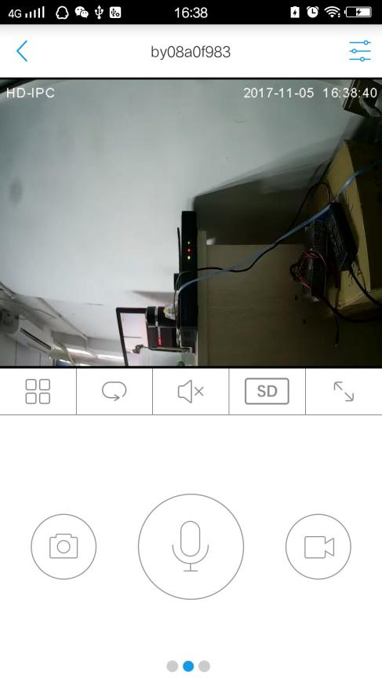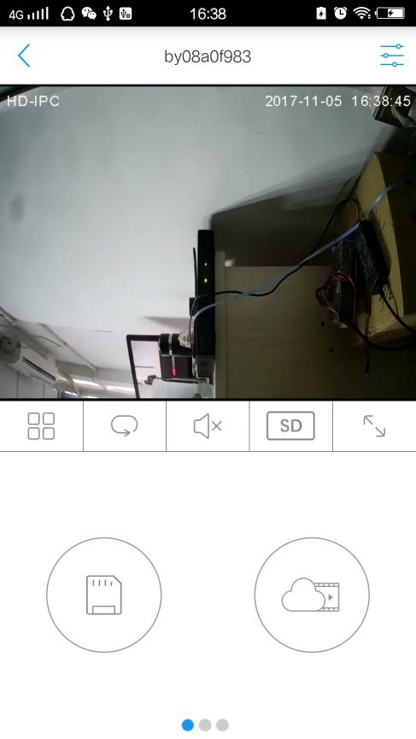
Live video- default Live video- Video playback
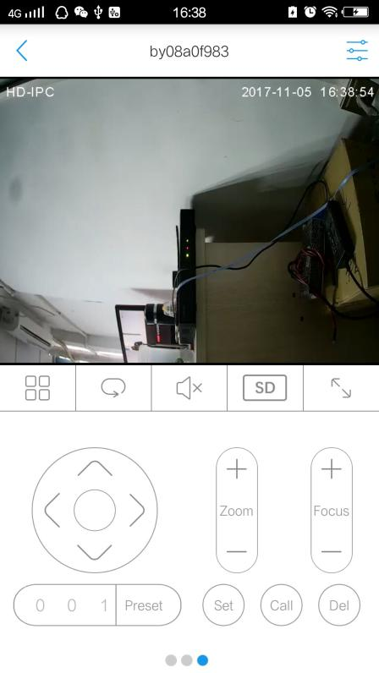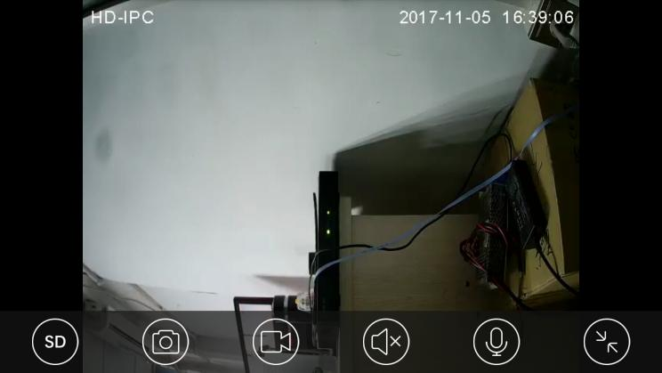

Live video- PTZ control Live video- full Screen

4.4.2 Panel Button Function Description.
In the live video window,they’re some function button that help user view or change device parameters and account parameters.Details description is follows.
Form 1
Button | Button | Button | Description
 | Back to device list |  | Device parameter config
/ | Singal or Multi-screen display | / | Polling on or off
/ | Audio on or off | / | SD video or HD video
 | Full screen |  | Intercom/PTZ/Playback switch

Form 2
Button | Description | Button | Description
/ | Intercom off or on |  | snap
/ | Record off or on |  | SDcard record
 | Cloud record |  | PTZ control
 | +：Zoom out  -：zoom in |  | +：Focus far  -：Focus near
 | Input preset number |  | Set,call,delete preset button

4.4 Alarm
Open the phone alarm:Click the "" button in main interface to enter the "System Settings", Turn on the enable alarm and alarm sound switch, then click the "Finish" button . APP would accept the alarm from device.
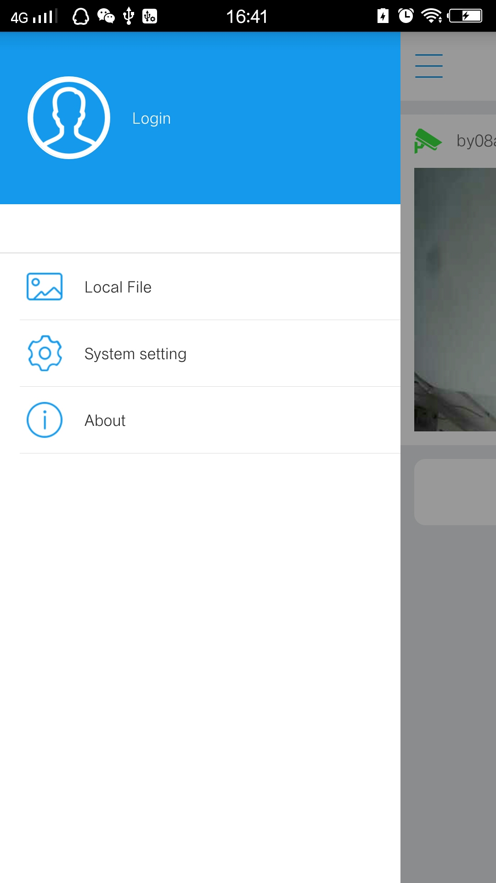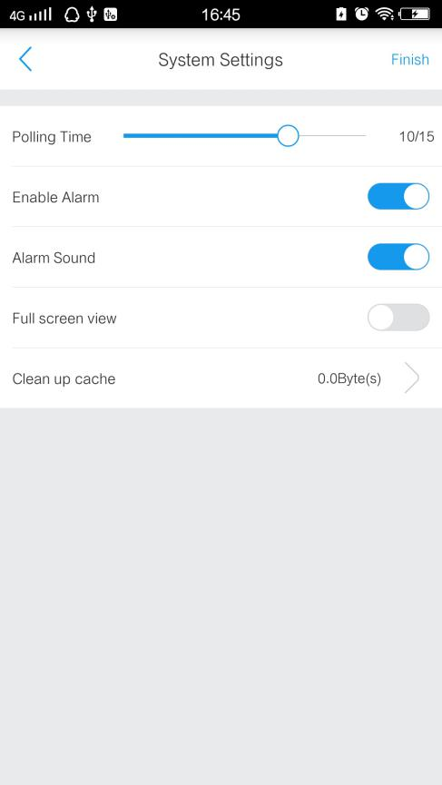
Turn on the device alarm: Select the device, click ""button, enter Advanced Settings -> Motion Detection window ,turn on alarm and set detection time.
When trigger alarm,mobile phone will show below, tap  to enter real-time video interface, or top  to shut up alarm.
TIP:Click the button"" on main interface ,you can view alarm history.

4.5. File management

4.5.1. Browsing
Click the "" icon in the main interface and then click the "Local Files" option to enter the browse page of snapshot photos and video files. Tap the corresponding device to open the corresponding picture or video file, or delete the file.
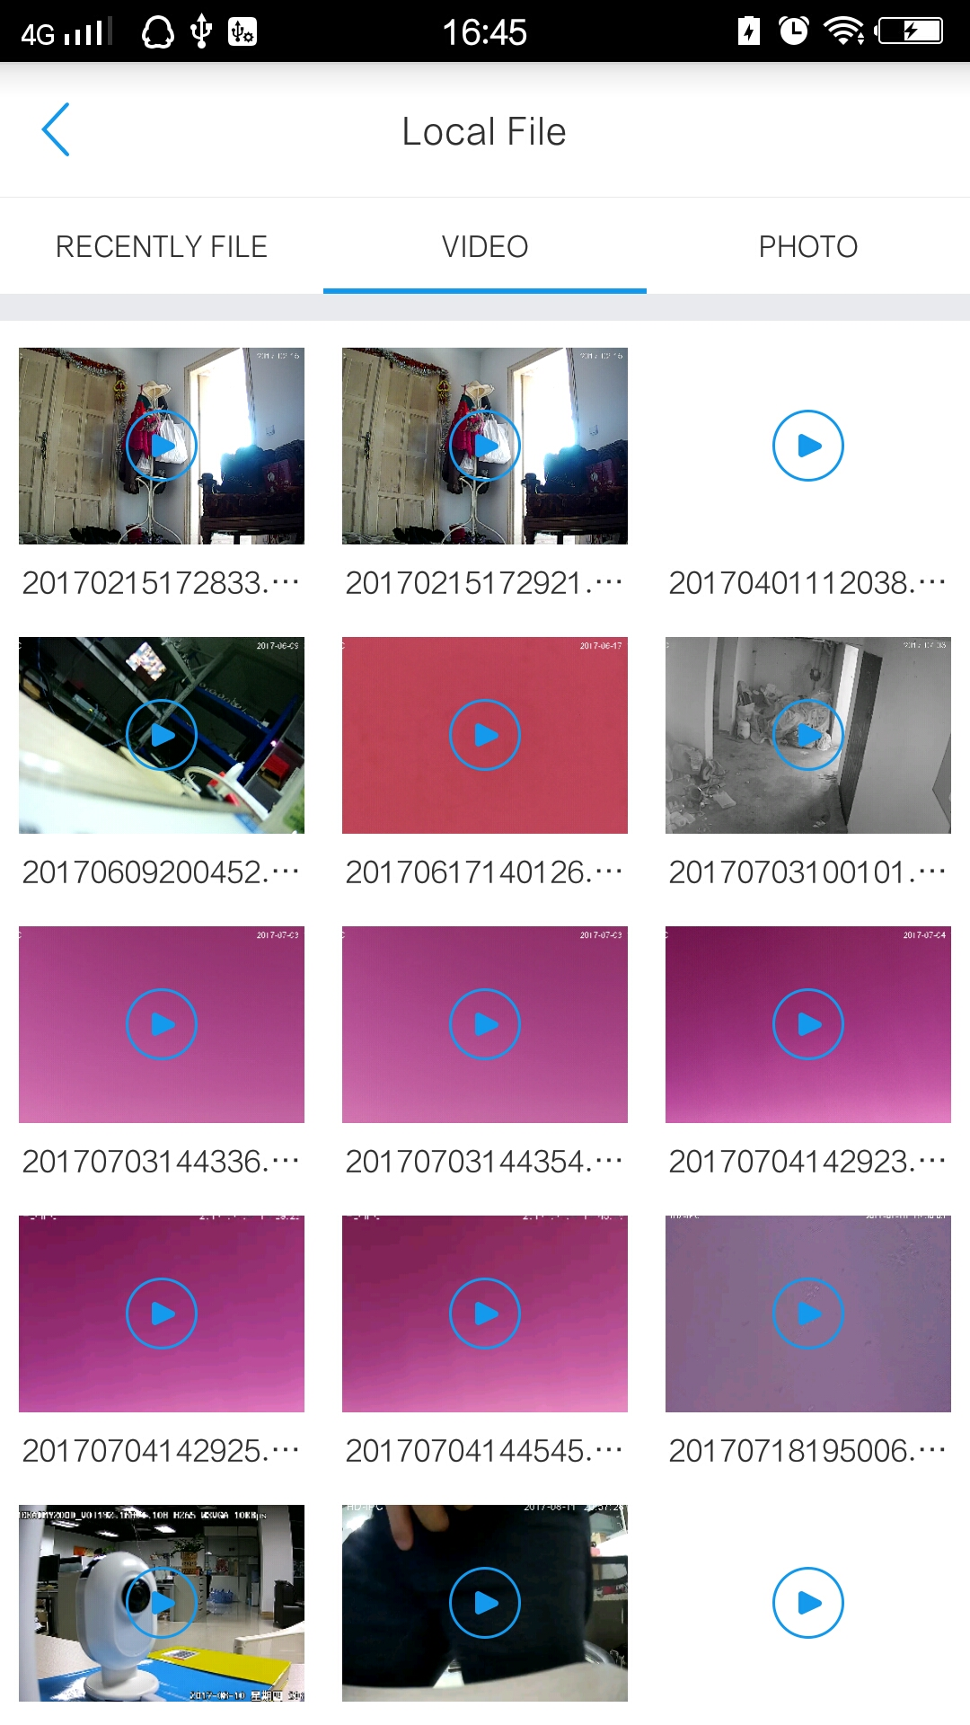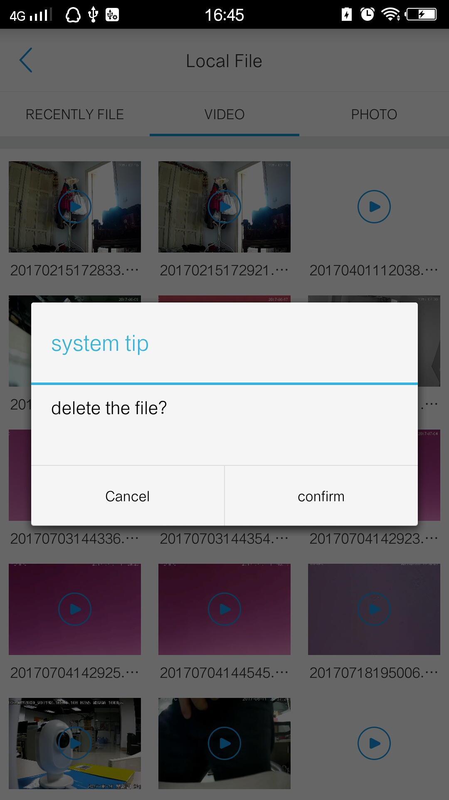
File browsing File delete

4.5.2. Delete
Longer time to press the files which want to delete, it will show confirm menu as above, tap confirm, files will remove.
4.6 Record playback
In the Live video window, click on "" recording icon, the playback window pop out. Select the record date you want to view , drag the record time bar to select the time, as shown below:
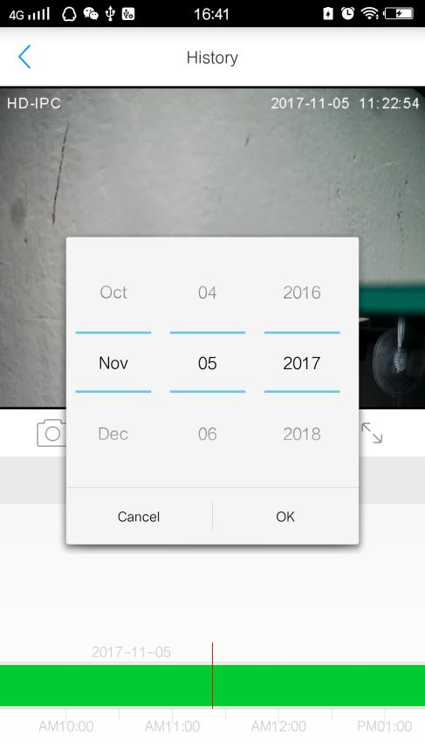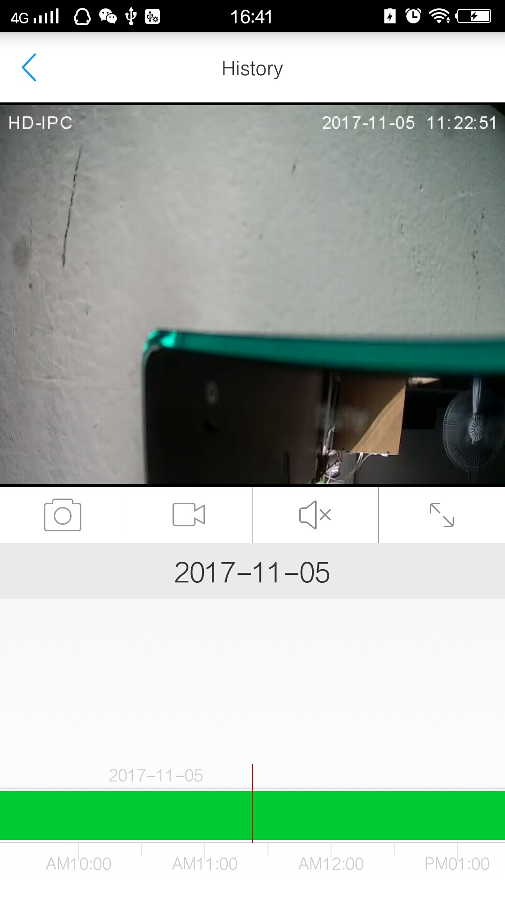
Select date and search Search results and playback

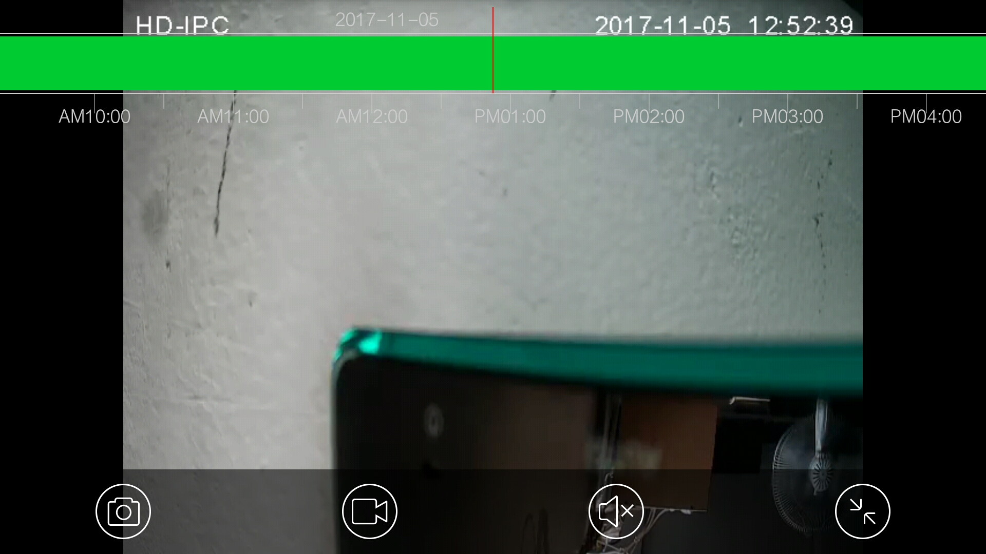
Record playback in full screen mode

